Team Meeting Log
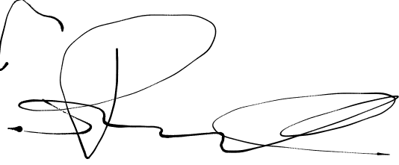  Group 3 | Meeting Log # | 1//2021 | Minutes
Team Members | Dane Manley | GUI skeleton | 
Team Members | Santiago Ramirez | Git Organization
Team Members | Daniel Espinel | Git Management/Readme | 
Team Members | Anthony Peterson | First Meeting (N/A) | AP
Topics Discussed

Obstacles Encountered

Finished Items

Unfinished Items

Notes

